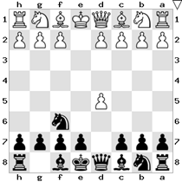

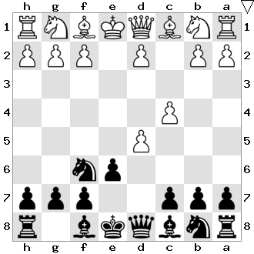

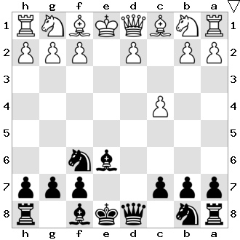

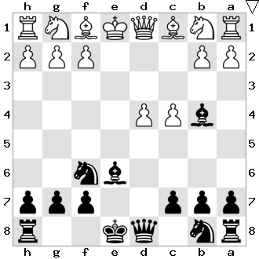

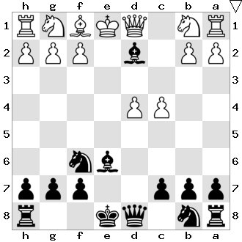

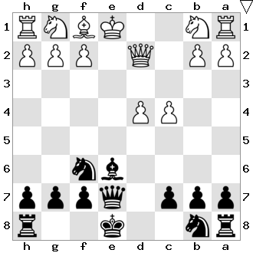

** DÉFENSE SCANDINAVE Variante : Gambit Islandais**

|  |  |  |  |  |
| --- | --- | --- | --- | --- |
|  |  |  |  | **1.e4 d5** |
|  |  | **2.e5** c5 | **2.d4** dxe4 | **2.exd5 Cf6** |
|  |  | 3.Cf3 Cc6 | 3.Cc3 e5 |  |
|  |  | 4.c3 Fg4 | 4.Cxe4 exd4 |  |
|  |  | 5.d4 e6 | 5.Cf3 Cc6 |  |
|  |  | 6.Fe2 FxF | 6.Fc4 Ff5 |  |
|  |  | 7.FxF cxd4 | 7.0-0 Fxe4 |  |
|  |  | 8.cxd4 Db6 | 8.Te1 Fe7 |  |
|  |  |  | 9.Txe4 Cf6 |  |
|  |  |  | 10.Te2 0-0 |  |
|  |  |  |  |  |
| **3.Cf3** Cxd5 | **3.Fb5+** Fd7 | **3.Cc3** Cxd5 | **3.d4** Fg4 | **3.c4 e6** |
| 4.d4 Ff5 | 4.Fc4 Fg4 | 4.Cxd5 Dxd5 | 4.Fe2 Fxe2 |  |
| 5.Fd3 Fxd3 | 5.f3 Fc8 | 5.Cf3 Cc6 | 5.Dxe2 Dxd5 |  |
| 6.Dxd3 c6 | 6.Cc3 Cbd7 | 6.Fe2 e5 | 6.Cf3 e6 |  |
| 7.c4 Cf6 | 7.De2 Cb6 | 7.d3 Ff5 | 7.0-0 Cc6 |  |
| 8.Cc3 e6 | 8.Dd3 g6 | 8.0-0 0-0-0 | 8.Cc3 Dh5 |  |
|  |  |  |  |  |
|  | **4.**Da4+ Fd7 | **4.Cf3** exd5 | **4.Cc3** exd5 | **4.dxe6 Fxe6** |
|  | 5.Db3 Ca6 |  |  |  |
|  | 6.Dxb7 Cc5 |  |  |  |
|  | 7.Db4 |  |  |  |
|  |  |  |  |  |
|  |  |  | **5.Cf3** De7 | **5.d4 Fb4+** |
|  |  |  | 6.De2 Cc6 |  |
|  |  |  | 7.d4 Ff5 |  |
|  |  |  | 8.Dxe7 Fxe7 |  |
|  | **9.Fe2** Fxf3 | **9.a3 ?** Cxf3 | **9.Fe3** 0-0-0 |  |
|  | 10. Fxf3 Cxd4 | 10.gxf3 Cxd4 | 10.Cbd2 Cb4 |  |
|  | 11.Fd1 |  | 11.Tc1 Cxa2 |  |
|  |  |  |  |  |
|  |  |  | **6.Cc3** Ce4 | **6.Fd2 Fxd2+** |
|  |  |  | 7.Dd3 Ff5 |  |
|  |  |  | 8.Df3 Cc6 |  |
|  |  |  | 9.Dxf5 Cxc3 |  |
|  |  |  | 10.Fe3 Cb5+ |  |
|  |  |  | 11.Rd1 Cbxd4 |  |
|  |  |  |  |  |
|  |  |  |  | **7.Dxd2 De7** |
|  |  |  |  | **8.De2 Cc6** |
|  |  |  |  | **9.Cf3 0-0-0** |
|  |  |  |  | **10.d5 The8** |
|  |  |  |  | **11.Cc3 Fxd5** |
|  |  |  |  | **12.Cxd5** |

Arrangement : René Maestre agrée F.F.E   
pour l’Échecs Club de Villeurbanne   
Destination : débutants et intermédiaires